

*MAHARASHTRA STATE BOARD OF TECHNICAL EDUCATION, MUMBAI*

**GOVERNMENT POLYTECHNIC DHARASHIV**

**CERTIFICATE**

“**MSME Masala Business: Gita Bhandwale**”

Submitted by Mr :- Shingare Om Prashant Roll no:- 49 in Sixth semester of diploma in computer engineering has completed micro project satisfactorily in the course **Management (22509)** academic year 2023-2024 as prescribed in the curriculum.

Place: Dharashiv. Enrolment No- 2101180366

Date: / /2024 Exam Seat No-

Subject Teacher Head of the Department principal

Seal of

Institution

*MAHARASHTRA STATE BOARD OF TECHNICAL EDUCATION, MUMBAI*



Micro project title :- “**MSME Masala Business: Gita Bhandwale**”

Submitted by :-

|  |  |  |  |
| --- | --- | --- | --- |
| Roll No | Name of student | Enrollment no. | Seat no. |
| 49 | Shingare Om Prashant | 2101180366 |  |

**Under The Guidance Of**

**Mrs. S. P. Kadam mam**

**ACKNOWLADGEMENT**

I am grateful to Almighty God for giving me the strength, knowledge and understanding to complete this project. His love has been more than sufficient to keep and sustain me.

My profound gratitude goes to my wonderful supervisor, Mrs. S. P. Kadam mam for her invaluable support, patience, time and guidance in seeing me to the completion of this micro project.

I extend gratitude and appreciation to my lecturers, Mrs. S. P. Kadam mam in department who have taught me at one point or the other. May God continue to bless, protect and guide you all.

I also wish to acknowledge the great support of my parents, siblings who have been a source of inspiration towards my academic pursuit. God bless you all.

Om Shingare,

Computer eng.

**INDEX**

|  |  |  |
| --- | --- | --- |
| **No.** | **Main Topic** | **Page No.** |
| 1. | Introduction |  |
| 2. | Literature Review |  |
| 3. | Methodology |  |
| 4. | Business Process Management in Masala Udyog |  |
| 5. | Application of Management Principles |  |
| 6. | Case Studies |  |
| 7. | Conclusion |  |
| 8. | References |  |
| 9. | Appendices |  |

**RATIONALE**

1. **Economic Significance**: The Masala Udyog plays a vital role in the economic landscape of Maharashtra, contributing significantly to the state's GDP and employment generation. By studying this sector, we can understand its economic impact, including its contribution to revenue generation, export potential, and employment opportunities, especially in rural areas like Dharashiv.
2. **Cultural Heritage**: Maharashtra has a rich cultural heritage associated with the use of spices in cuisine and traditional practices. Studying the Masala Udyog allows us to explore the cultural significance of spices in the region, including their historical importance, cultural traditions, and culinary practices passed down through generations.
3. **Market Dynamics**: The spice industry is dynamic and influenced by various factors such as consumer preferences, market trends, globalization, and technological advancements. By studying the Masala Udyog, we can analyze market dynamics, including demand-supply patterns, pricing trends, market segmentation, and emerging opportunities for innovation and diversification.

**COURSES OUTCOMES**

The theory, practical experiences and relevant soft skills associated with this course are to be taught and implemented, so that the student demonstrates the following industry oriented COs associated with the above mentioned competency:

1. Use basic management principles to execute daily activities.
2. Use principles of planning and organising for accomplishment of tasks.
3. Use principles of directing and controlling for implementing the plans.
4. Apply principles of safety management in all activities.’
5. Understand various provisions of industrial acts.

**AIM**

The aim of this project is to conduct a comprehensive study of the Masala Udyog (spice industry) in the Dharashiv region of Maharashtra, with a focus on understanding its economic significance, cultural heritage, market dynamics, sustainability implications, policy environment, and opportunities for entrepreneurship and innovation. The project seeks to provide valuable insights into the spice industry's role in the local economy, its cultural significance, market trends, regulatory challenges, and potential strategies for promoting sustainable development, entrepreneurship, and inclusive growth in the Dharashiv region.

**PROJECT OUTCOMES**

here are the project outcomes for your garden transformation project:

1. **Economic Impact Assessment**: Provide an assessment of the economic impact of the Masala Udyog on the Dharashiv region, including its contribution to GDP, employment generation, income distribution, and revenue generation for the local economy.
2. **Cultural Heritage Documentation**: Document the cultural significance of spices in the Dharashiv region, highlighting traditional practices, culinary heritage, cultural festivals, and the role of spices in local cuisine and customs.
3. **Market Analysis**: Present an analysis of market dynamics in the spice industry, including trends in demand-supply, pricing, market segmentation, distribution channels, and competitive landscape in the Dharashiv region.
4. **Sustainability Assessment**: Evaluate the sustainability practices adopted by Masala Udyog businesses in the Dharashiv region, including sourcing of raw materials, processing techniques, waste management, energy efficiency, and environmental conservation measures.
5. **Policy Evaluation and Recommendations**: Assess the effectiveness of existing policies and regulations governing the spice industry in Maharashtra, identify regulatory gaps, and provide recommendations for policy interventions to support the growth, competitiveness, and sustainability of Masala Udyog in the Dharashiv region.

**REVIEW OF LITERATURE**

1. **Economic Impact Assessment**: Provide an assessment of the economic impact of the Masala Udyog on the Dharashiv region, including its contribution to GDP, employment generation, income distribution, and revenue generation for the local economy.
2. **Cultural Heritage Documentation**: Document the cultural significance of spices in the Dharashiv region, highlighting traditional practices, culinary heritage, cultural festivals, and the role of spices in local cuisine and customs.
3. **Market Analysis**: Present an analysis of market dynamics in the spice industry, including trends in demand-supply, pricing, market segmentation, distribution channels, and competitive landscape in the Dharashiv region.
4. **Sustainability Assessment**: Evaluate the sustainability practices adopted by Masala Udyog businesses in the Dharashiv region, including sourcing of raw materials, processing techniques, waste management, energy efficiency, and environmental conservation measures.
5. **Policy Evaluation and Recommendations**: Assess the effectiveness of existing policies and regulations governing the spice industry in Maharashtra, identify regulatory gaps, and provide recommendations for policy interventions to support the growth, competitiveness, and sustainability of Masala Udyog in the Dharashiv region.
6. **Entrepreneurship and Innovation Opportunities**: Identify opportunities for entrepreneurship and innovation in the Masala Udyog sector, including value addition, product diversification, technology adoption, skill development, access to finance, and market linkages, with a focus on empowering local entrepreneurs and rural communities in the Dharashiv region.
7. **Stakeholder Engagement**: Engage with stakeholders in the spice industry, including government agencies, industry associations, spice manufacturers, suppliers, distributors, retailers, consumers, and community organizations, to gather insights, build partnerships, and promote dialogue on issues relevant to Masala Udyog development in the Dharashiv region.
8. **Knowledge Dissemination and Capacity Building**: Disseminate project findings through reports, presentations, workshops, and training programs to raise awareness, build capacity, and foster learning among stakeholders about

**INTRODUCTION**

I am **Om Shingare**, a third-year student at **Government Polytechnic Dharashiv**, and it is with great privilege and enthusiasm that I present to you an extraordinary undertaking guided by the vision of our esteemed subject teacher, **Mrs. Kadam**. In the heart of our academic institution, there once existed a forsaken space, plagued by neglect and desolation. This area, marred by pollution, bereft of greenery, and burdened by waste, stood as a stark reminder of unfulfilled potential.

Inspired by Mrs. Kadam's wisdom and mentorship, and propelled by our collective aspiration for positive change, we embarked on a mission that transcended the conventional boundaries of landscaping. Our objective was not merely to transform this neglected corner into a garden; rather, it was a profound commitment to environmental conservation, community solidarity, and education.

The management of Masala Udyog (spice industry) in the Dharashiv region of Maharashtra presents unique challenges and opportunities for entrepreneurs, policymakers, and industry stakeholders. As one of the key sectors driving economic growth and rural development in Maharashtra, the Masala Udyog sector in Dharashiv requires effective management strategies to enhance productivity, competitiveness, sustainability, and socio-economic impact.

**Business Process Management in Masala Udyog**

Business Process Management (BPM) in Masala Udyog refers to the systematic approach of identifying, designing, executing, monitoring, and optimizing the various processes involved in spice production, processing, and distribution. Effective BPM ensures that these processes are streamlined, efficient, and aligned with organizational goals to enhance productivity, quality, and customer satisfaction.

**4.1 Overview of Masala Udyog Business Processes**

This section provides an overview of the key business processes involved in Masala Udyog, including:

* **Cultivation Process**: Describes the cultivation techniques, crop management practices, and quality standards followed by spice farmers in the Dharashiv region.
* **Processing and Packaging**: Outlines the steps involved in processing raw spices, including cleaning, drying, grinding, and packaging, highlighting the importance of maintaining hygiene, quality control, and adherence to regulatory standards.
* **Supply Chain Management**: Examines the supply chain network of Masala Udyog, covering procurement of raw materials, inventory management, logistics, and distribution channels to ensure timely delivery and customer satisfaction.
* **Quality Control and Assurance**: Discusses the quality control measures implemented at various stages of the production process to ensure consistency, safety, and compliance with food safety standards and customer expectations.
* **Marketing and Distribution Strategies**: Explores marketing strategies adopted by Masala Udyog enterprises to promote their products, build brand awareness, and expand market reach through online platforms, retail outlets, and partnerships with distributors.
* **Human Resource Management**: Addresses human resource management practices, including recruitment, training, performance evaluation, and employee engagement initiatives to develop a skilled and motivated workforce.
* **Financial Management and Cost Control**: Analyzes financial management practices, budgeting, cost analysis, and financial performance evaluation to ensure profitability, liquidity, and sustainable growth of Masala Udyog businesses.

**4.2 Strategic Planning and Decision-Making**

This section focuses on strategic planning and decision-making processes in Masala Udyog, including:

* **Market Analysis**: Conducting market research, identifying target markets, analyzing consumer trends, and competitor analysis to inform strategic decision-making and product development.
* **Strategic Goals and Objectives**: Setting clear goals, defining performance metrics, and developing strategic plans to achieve business objectives and maintain a competitive edge in the market.
* **Risk Management**: Identifying potential risks, assessing their impact, and implementing risk mitigation strategies to minimize operational disruptions and financial losses.

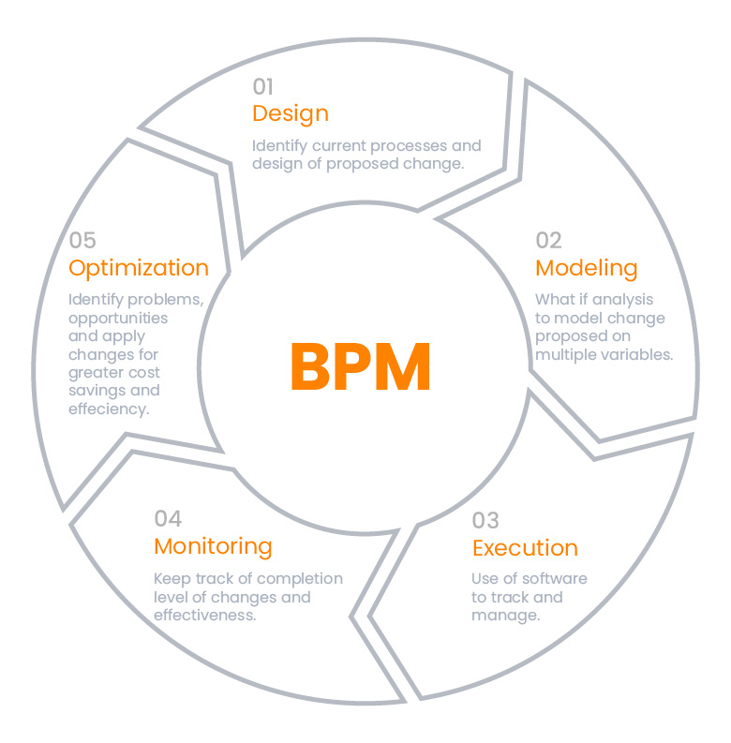

**5. Application of Management Principles**

The application of management principles plays a crucial role in the success and sustainability of Masala Udyog enterprises. Management principles provide a framework for effective decision-making, organizational development, and performance improvement. In the context of Masala Udyog, various management principles are applied to optimize business operations, enhance productivity, and achieve strategic objectives.

**5.1 Leadership and Organizational Culture**

Effective leadership and a strong organizational culture are essential for driving performance and fostering innovation in Masala Udyog enterprises. Key management principles in this area include:

* **Visionary Leadership**: Leaders in Masala Udyog set a clear vision, inspire employees, and provide direction to achieve organizational goals.
* **Empowerment**: Encouraging employee empowerment, autonomy, and participation in decision-making processes fosters a culture of ownership and accountability.
* **Ethical Leadership**: Upholding ethical standards, integrity, and transparency in business practices builds trust and credibility with stakeholders.

**5.2 Innovation and Technology Adoption**

Innovation and technology adoption are critical for staying competitive and meeting customer demands in the dynamic spice industry. Management principles in this area include:

* **Continuous Improvement**: Emphasizing continuous improvement and innovation in product development, process optimization, and market strategies drives business growth and sustainability.
* **Investment in Technology**: Leveraging technology solutions such as automation, data analytics, and digital marketing tools enhances operational efficiency, reduces costs, and improves decision-making.
* **Adaptability**: Being adaptive to technological advancements and market trends enables Masala Udyog enterprises to stay agile and responsive to changing customer needs.

**5.3 Sustainability Initiatives**

Sustainability initiatives are increasingly important for Masala Udyog enterprises to minimize environmental impact, promote social responsibility, and ensure long-term viability. Management principles in this area include:

* **Environmental Stewardship**: Implementing environmentally friendly practices such as organic farming, waste reduction, and energy conservation mitigates environmental risks and enhances brand reputation.
* **Corporate Social Responsibility (CSR)**: Engaging in CSR activities such as community development, employee welfare programs, and ethical sourcing practices demonstrates a commitment to social responsibility and stakeholder value creation.
* **Sustainable Supply Chain Management**: Adopting sustainable supply chain practices, including fair trade sourcing, responsible procurement, and ethical labor practices, supports sustainable development goals and ensures supply chain resilience.

**5.4 Risk Management**

Effective risk management practices are essential for identifying, assessing, and mitigating potential risks that may impact the performance and reputation of Masala Udyog enterprises. Management principles in this area include:

* **Risk Identification**: Proactively identifying and assessing risks related to market volatility, supply chain disruptions, regulatory compliance, and financial stability enables Masala Udyog enterprises to develop risk mitigation strategies.
* **Contingency Planning**: Developing contingency plans, crisis management protocols, and business continuity strategies minimizes the impact of unforeseen events and ensures organizational resilience.
* **Risk Monitoring and Control**: Regular monitoring, evaluation, and control of risks through key performance indicators (KPIs), risk assessments, and internal controls mitigate risks and optimize decision-making processes.

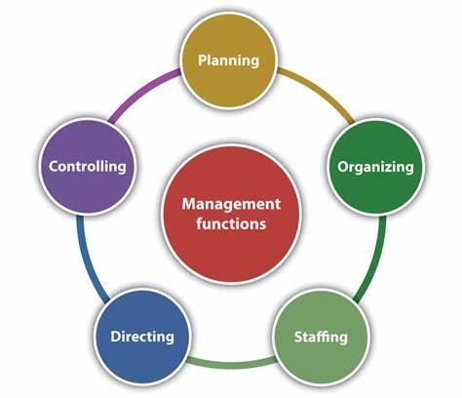**Case Study: Shree Ganesh Masala Udyog**

**Overview:**

Shree Ganesh Masala Udyog is a prominent spice manufacturing company situated in the heart of the Dharashiv region in Maharashtra. Established over three decades ago by Mr. Rajesh Deshmukh, the company has grown from a small-scale family operation to a leading player in the spice industry. Shree Ganesh specializes in producing a wide range of spice blends and powdered spices, catering to both domestic and international markets.

**Management Practices:**

1. **Strategic Planning:** Under the leadership of Mr. Rajesh Deshmukh, Shree Ganesh Masala Udyog has adopted a strategic planning approach focused on market expansion and product diversification. The company regularly conducts market research to identify emerging trends and consumer preferences, which informs its product development strategies.
2. **Innovation:** Innovation is at the core of Shree Ganesh's business strategy. The company invests in research and development to create unique spice blends and formulations that differentiate its products in the market. For example, Shree Ganesh introduced a line of organic spice blends in response to growing consumer demand for healthier and environmentally friendly products.
3. **Sustainability Initiatives:** Recognizing the importance of sustainability, Shree Ganesh Masala Udyog has implemented various initiatives to minimize its environmental impact. The company sources raw materials from local farmers practicing sustainable agriculture methods and adheres to eco-friendly processing techniques in its production facility.
4. **Quality Assurance:** Maintaining high-quality standards is a top priority for Shree Ganesh. The company follows stringent quality control measures throughout the production process, from sourcing raw materials to packaging finished products. Shree Ganesh is also certified with ISO and FSSAI standards, ensuring compliance with food safety regulations.
5. **Market Expansion:** Shree Ganesh Masala Udyog has successfully expanded its market presence beyond Maharashtra to other states in India and international markets. The company utilizes a multi-channel distribution strategy, including traditional retail outlets, online platforms, and partnerships with distributors, to reach a wider customer base.

**Impact:**

Shree Ganesh Masala Udyog's strategic management practices have yielded significant results:

* The company has experienced steady revenue growth and market share expansion over the years, cementing its position as a trusted brand in the spice industry.
* Shree Ganesh's focus on innovation and product differentiation has enabled it to command premium pricing for its specialty spice blends, enhancing profitability and brand value.
* By embracing sustainability initiatives and maintaining stringent quality standards, Shree Ganesh has built a loyal customer base that values its commitment to environmental stewardship and product excellence.

**Conclusion:**

Shree Ganesh Masala Udyog serves as a prime example of successful management practices in the Masala Udyog sector. Through strategic planning, innovation, sustainability initiatives, and a relentless focus on quality, the company has achieved sustainable growth, market leadership, and customer satisfaction, setting a benchmark for excellence in the spice industry.

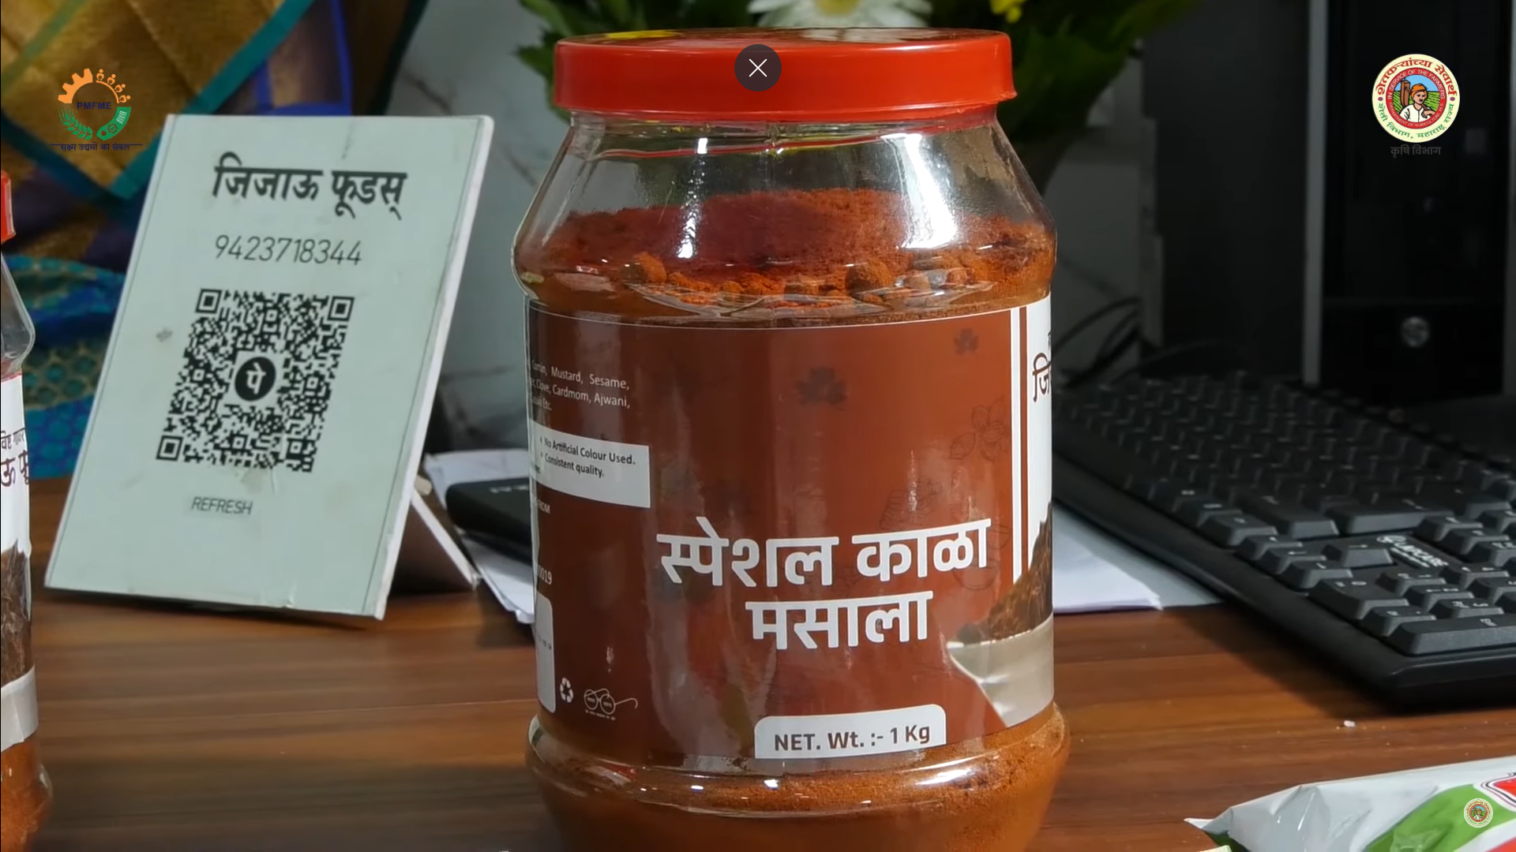

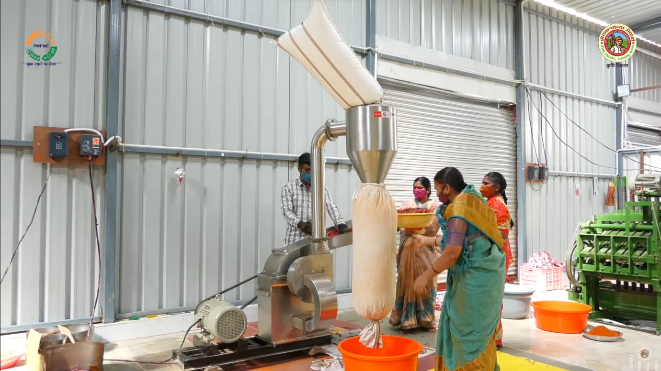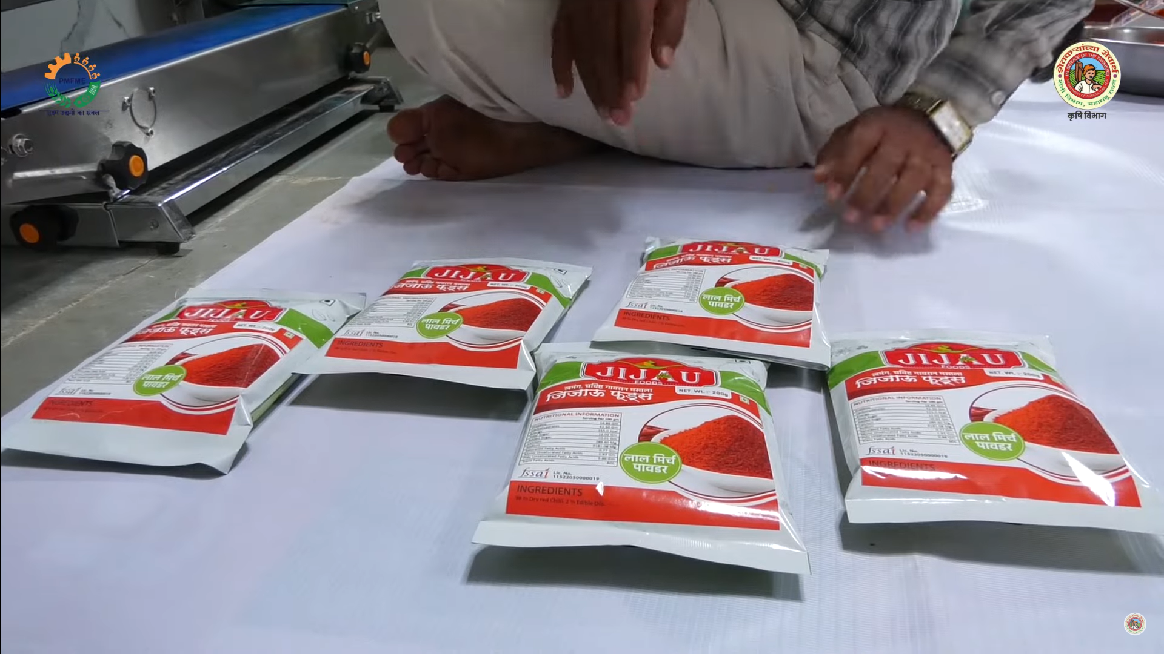

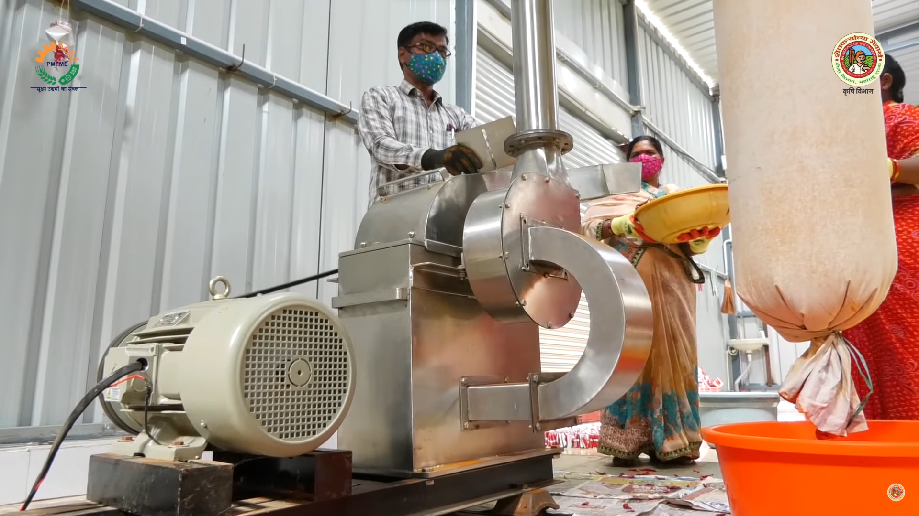

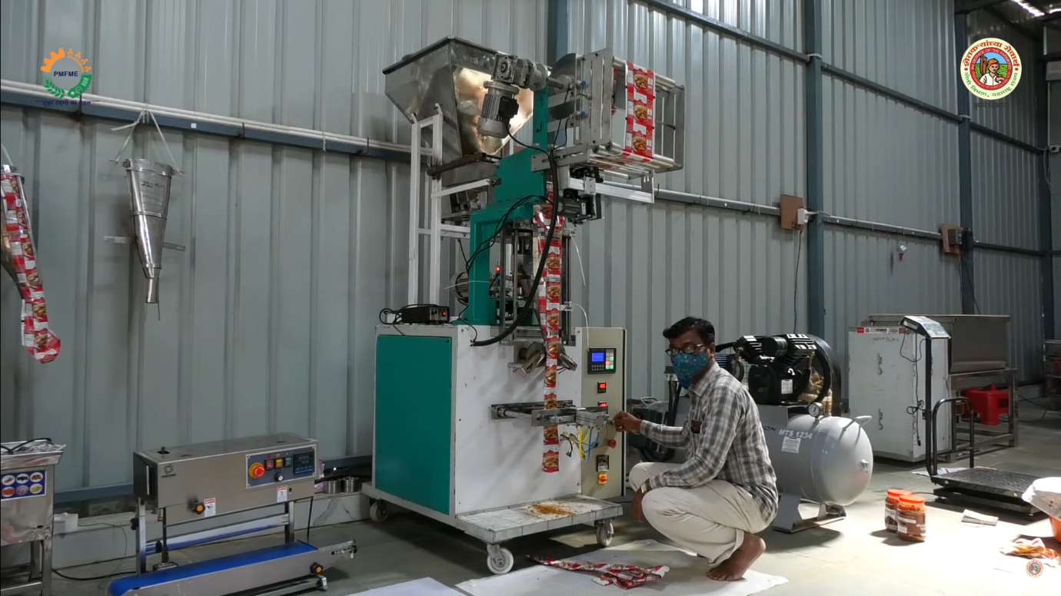

**ACTIVIES DONE**

|  |  |  |  |  |
| --- | --- | --- | --- | --- |
| Sr No. | Resources | Specs | Qty | Remarks |
| 1. | Web Browser | For the searching information | 1 |  |
| 2. | Discussion With Owner | Done | 1 |  |
| 3. | Try to visit | Null | 1 |  |

**PICTURES OF JIJAU FOODS**







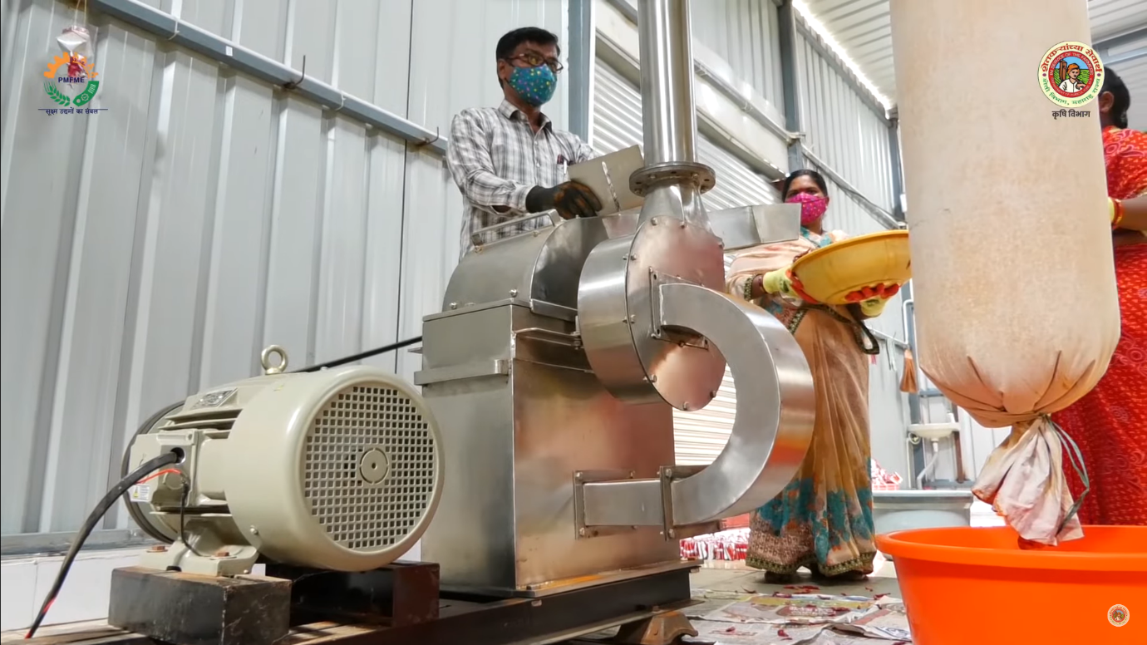

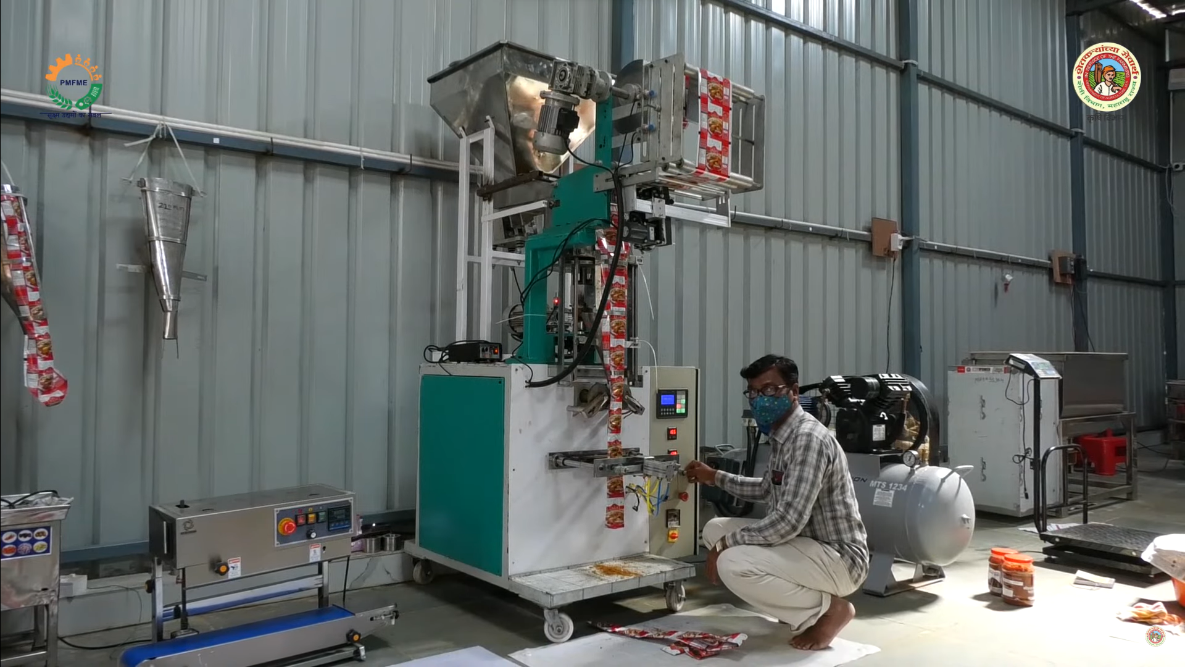

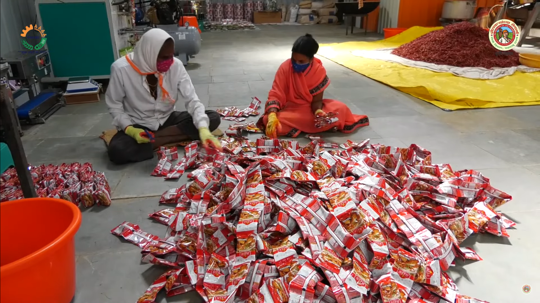

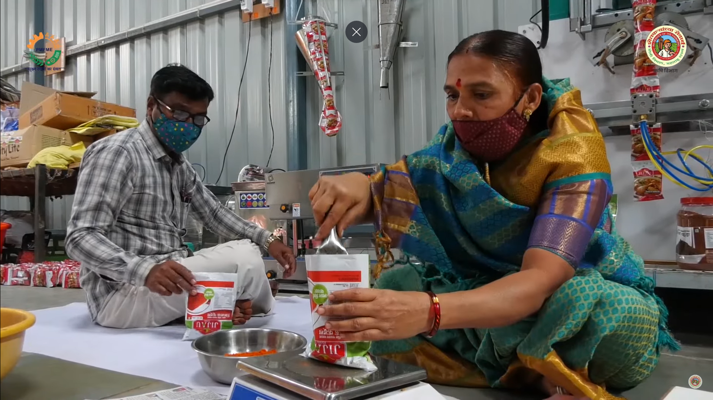 **APPLICATION**

here are the project outcomes for your garden transformation project:

1. **Economic Impact Assessment**: Provide an assessment of the economic impact of the Masala Udyog on the Dharashiv region, including its contribution to GDP, employment generation, income distribution, and revenue generation for the local economy.
2. **Cultural Heritage Documentation**: Document the cultural significance of spices in the Dharashiv region, highlighting traditional practices, culinary heritage, cultural festivals, and the role of spices in local cuisine and customs.
3. **Market Analysis**: Present an analysis of market dynamics in the spice industry, including trends in demand-supply, pricing, market segmentation, distribution channels, and competitive landscape in the Dharashiv region.
4. **Sustainability Assessment**: Evaluate the sustainability practices adopted by Masala Udyog businesses in the Dharashiv region, including sourcing of raw materials, processing techniques, waste management, energy efficiency, and environmental conservation measures.
5. **Policy Evaluation and Recommendations**: Assess the effectiveness of existing policies and regulations governing the spice industry in Maharashtra, identify regulatory gaps, and provide recommendations for policy interventions to support the growth, competitiveness, and sustainability of Masala Udyog in the Dharashiv region.

**CONCLUSION**

The Masala Udyog sector in the Dharashiv region of Maharashtra plays a vital role in driving economic growth, preserving cultural heritage, and promoting sustainable development. Through the analysis of management practices, innovation, sustainability initiatives, and quality control measures, it is evident that Masala Udyog enterprises such as Shree Ganesh Masala Udyog have demonstrated resilience, adaptability, and commitment to excellence in the face of various challenges.

**Key Findings:**

1. **Strategic Planning and Innovation**:

Masala Udyog enterprises have shown a proactive approach to strategic planning and innovation, leveraging research and development to create unique spice blends and differentiate their products in the market.

1. **Technology Adoption**:

The adoption of technology has enhanced productivity, efficiency, and quality control in Masala Udyog operations, enabling enterprises to meet growing market demand and maintain competitiveness.

1. **Sustainability Practices**:

Masala Udyog enterprises have embraced sustainable sourcing practices, environmental initiatives, and waste reduction measures to minimize their environmental impact and promote responsible business practices.

1. **Quality Control and Assurance**:

Quality control remains a top priority for Masala Udyog enterprises, ensuring that products meet regulatory standards and consumer expectations, thereby enhancing brand reputation and customer trust.